**DIGITAL TIMER FOR PHOTOGRAPHIC ENLARGERS**

DISPARATIMER

USER MANUAL

V1.0

INDEX

0. Introduction and requirements 1

1. Installing the Raspberry software and connection scheme 1

1.1 Raspberry Pico W/WH micropython firmware update 1

1.2 Installing the Raspberry W/WH program with Thonny 2

1.3 Recommended connection scheme. 3

2 Operation of DisparaTimer 4

2.1 TIMER mode 5

2.1.1 Set the time and start the exposure 6

2.1.2 “+/-“ buttons 6

2.1.3 Use of memories 6

2.2 STRIP mode 6

2.2.1 Methods to perform a test strip 8

3 Additional resources 8

# Introduction and requirements

DisparaTimer is an app for Android mobiles. When connected to a Raspberry Pico W/WH, it is capable of controlling the exposure time of a photo enlarger through a power relay.

**Requirements**

* Smartphone with Android 9 operating system or higher. Minimum screen size of 5 inches and minimum resolution of 1280x720 pixels.
* Raspberry Pico W o WH microcontroller.
* Computer with USB connection and Linux, MacOS or Windows operating system to install the Raspberry program.
* 1-channel AC power relay controlled by a 3.3V DC circuit.

# Installing the Raspberry software and connection scheme

## Raspberry Pico W/WH micropython firmware update

It is not a mandatory step, but it may be convenient to update the Raspberry micropython firmware that includes the latest fixes and improvements.

First, connect the Raspberry to the computer using the mini-USB cable while holding down the BOOTSEL button. A new storage drive "RPI-RP2" or similar will appear on the computer.

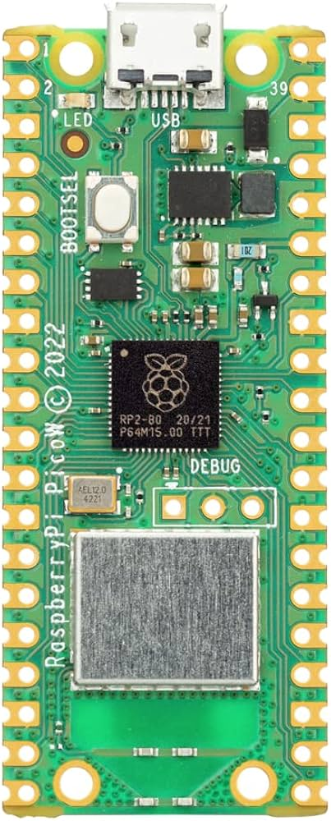 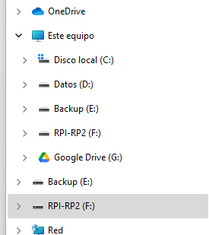

BOOTSELsel

1. (b)

Figure 1: (a) Rasbery Pico W BOOTSEL button. (b) “RPI-RP2” drive on Windows 11.

Then, download from <https://micropython.org/download/RPI_PICO_W/> the last version available in “Releases” section.

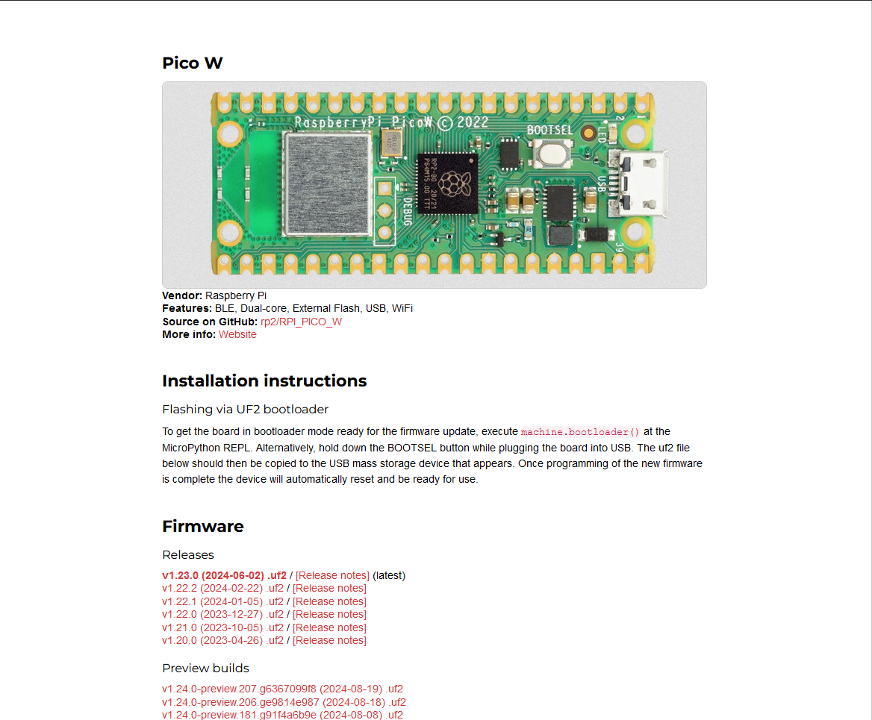

Figure 2: How micropython firmware for Rasberry Pico W website looks like.

Copy the downloaded file to the Raspberry drive. It will close and the Raspberry will restart in normal mode.

## Installing the Raspberry W/WH program with Thonny

Download Thonny IDE for your operating system from the official website <https://thonny.org/> and install it on your computer. Connect the Raspberry to your computer before opening Thonny for the first time.

Check at the bottom right part of Thonny screen that Micropython (Raspberry Pi Pico) is selected, and not "Local Python". See figure 3.

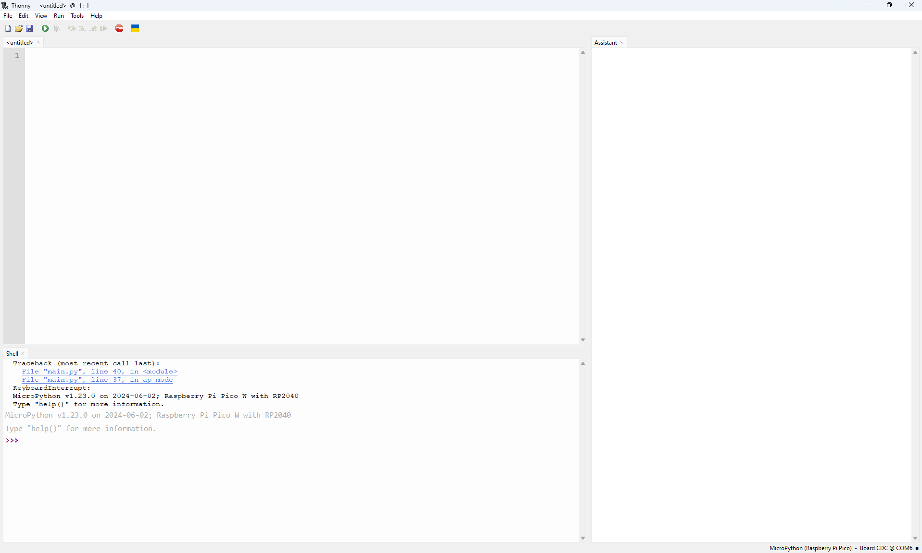

Figure 3: Bottom right side where Thonny actual connection is.

Download “main.py” file from the DisparaTimer Github page:

<https://github.com/visogonzalez/DisparaTimer/tree/master/Raspberry>

Open the file with Thonny: File🡪Open🡪This Computer.

Save the file in the Raspberry, File🡪Save As🡪Raspberry Pico. Use the name “main.py”. **Important!: any other name will not be executed by the Raspberry**.

Close Thonny and unplug the Raspberry. If we have proceeded correctly, when the Raspberry is connected again, a green LED should light up and a new WiFi network called “DISPARA” will be available.

## Recommended connection scheme.

* Smartphone-Raspberry: Connect to “DISPARA” network. Password “DISPARAFILM”. Disable Xiaomi's-like "Stay Connected" options that bypass connections without internet.
* Raspberry-Relay: According to figure 4.
* Relay-Enlarger: According to figure 4 with 1-1,5 mm de diameter cable.
* Relay-Safey light: According to figure 4 with 1-1,5 mm de diameter cable.

Figure 4: Connections scheme.

# Operation of DisparaTimer

DisparaTimer has two operational modes, "TIMER" and "STRIP", which are selected by clicking on **(7)** as shown in figure 5. The first one is the traditional timer mode, where you set a time to be used in each exposure. The second one is to perform test strips with constant increments of fraction of stop over a base time.

The app resizes depending on the screen dimensions, but it may not be enough on some devices. To improve the aspect, modify the screen zoom within the phone or tablet settings. The app will close when pressing **(4)** or **(5)** if your phone is not connected to a WiFi network.

## TIMER mode

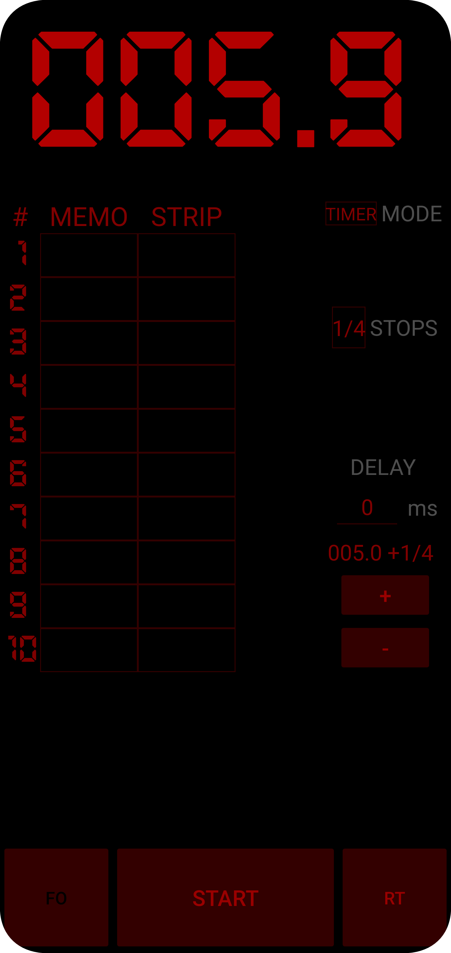

1. **Exposure Time.**
2. **Memories.**
3. **Test strip steps.**
4. **Focus.**
5. **Exposure start.**
6. **Reset.**
7. **DisparaTimer mode.**
8. **Fractions of stop.**
9. **Exposure delay.**
10. **Time modifications with fractions of stop.**

Figure 5: TIMER mode screen.

### Set the time and start the exposure

Tap on the top or bottom of each digit in **(1)** to increase or decrease by one unit. Once the desired time has been set, press **(5)** to start the exposure. You can also select the times of a previous test strip by clicking on the desired box in column **(3).** A delay at the start of exposure can be set in **(9)** indicating the desired amount in milliseconds.

The exposure can be stopped by pressing **(5)** when it indicates "PAUSE"; resume it by pressing **(5)** when it indicates "RESUME"; or cancel it by pressing **(6)** with **(5)** on "PAUSE". In this mode there is an acoustic signal after every second to facilitate performing dodge and burning.

### “+/-“ buttons

The time set in **(1)** can be increased or decreased by fractions of a stop with the use of buttons **(10).** The stop fraction to be used is defined in **(8)** and it also indicates how much the initial time has been increased or decreased. This indication resets when the time is changed in **(1)** or the stop fraction is changed in **(8)**.

### Use of memories

The TIMER mode has 10 memories to store the time displayed in **(1),** just do a long touch on a box of column **(2).** If there is a stored value, it is overwritten with the current one. To retrieve the time from a memory, perform a simple touch on the corresponding box of column **(2)** and the value will be transferred to **(1)**.

All values of **(2)** and **(3)** can be cleared with a long touch on **(6)**.

## STRIP mode

With the STRIP mode, test strips can be made to adjust the exposure time of the print. It is non-linear strip increasing the base time according to fractions of stop.

Test strip base time is set the same way as indicated in section 2.1.1 and each step is automatically recalculated. The number of steps to perform and the fraction of stop to increase in each step are defined in **(13)** and **(8)** respectively.

When switching to TIMER mode, the total times of each step are placed in column **(3)**.

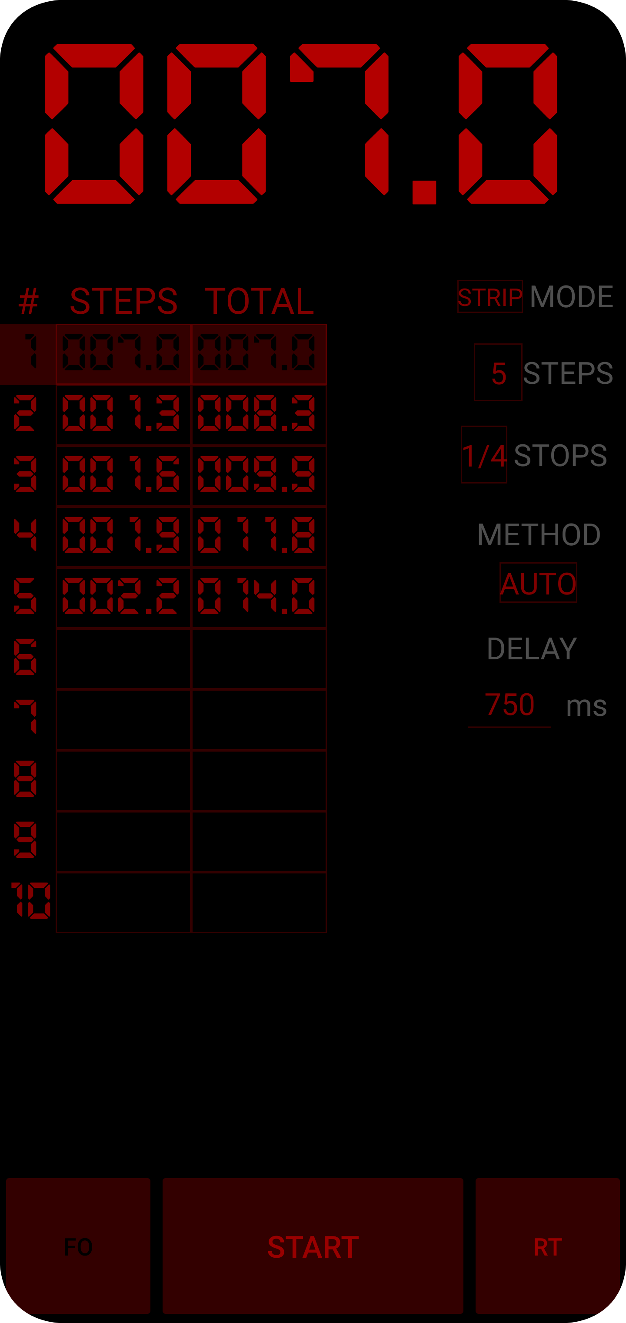

1. **Step partial time.**
2. **Step accumulated time.**
3. **Steps of the test strip.**
4. **Test strip method.**

Figure 6: STRIP mode screen.

### Methods to perform a test strip

In **(14)** three methods can be selected.

* MANUAL: Each step must be started manually by pressing **(1)**.
* SINGLE: Same as MANUAL, but each step applies the total time. For fine-tuning of specific areas of a photo.
* AUTO: Each step is automatically started after applying the delay value set in **(9)**. It is the default method of STRIP mode with 750 ms delay.

AUTO and MANUAL/SINGLE apply different delays that are remembered as long as the application is not closed.

# Additional resources

For additional information and educational videos on the different aspects of DisparaTimer, visit the webpage <https://www.disparafilm.com/disparatimer/> (Spanish language).